BUDGET VS ACTUAL PERFORMANCE ANALYSIS
PROBLEM STATEMENT
- Many Small-Scale Business Prepare Budgets to Monitor and Evaluate Their Business Performance, Profits, Sales and Revenue. However, As the Business Operates, They Noticed That the Stocks Are Moving Out and Sales Is Happening but Profitability Declines. Till Then They Did Not Maintained a Proper Analysis Report. Due To Improper Analysis, They Face Many Financial Discrepancies and The Cashflow Got Affected and At One Point They Started to Invest Owners Capital Contribution to Overcome Business Loses. The Investigation Point Started Increasing Because Of Unplanned Budget and Unnoticeable Variance Started Increasing.
- As These Unplanned Variance Continue to Increase, It Becomes Difficult for Business Owners to Identify the Actual Reasons Behind the Deviation.
- Therefore, The Key Problem Is to Analyse the Gap Between Planned and Actual Business Performance Analysis and Identify the Major Factor Contributing to the Decline in Cashflow.
OBJECTIVE
To analyse the budgeted and actual financial performance of a small-scale business by identifying budget variances, overspending, underutilization, and the key reasons for budget deviations. The project also aims to evaluate cash flow, supplier price variations, and product-wise sales and profitability to support better financial planning, cost control, and data-driven decision-making.
1.Budget Variance Analysis: Compare planned budgets with actual expenses to identify overspending and underutilization.
2.Root Cause Analysis: Identify the major reasons for budget deviations.
3.Cash Flow Analysis: Evaluate cash inflows, cash outflows, and the owner's capital contribution.
4.Supplier Price Analysis: Compare planned and actual purchase prices to identify supplier price variations.
5.Sales and Profitability Analysis: Evaluate product-wise revenue, costs, and profitability.
6.Decision-Making: Provide insights to improve budget planning, control expenses, and manage working capital effectively.
Solutions
- Expense Category Budget Overspending Analysis
- Expense Category Budget Underutilization Analysis
- Expense Category-Wise Budget Variance Analysis
- Root Cause Analysis of Budget Deviation
- Working Capital and Cash Flow Analysis
- Supplier Price Variance Analysis
- Product-Wise Sales and Profitability Analysis
METHODOLOGY
DATA COLLECTION: I collected my dataset from ChatGPT
DATA UNDERSTANDING: Reviewed the dataset structure and understood the purpose of each column.
Identified key financial variables such as Planned Budget, Actual Expense, Revenue, Cost, Profit, Cash Inflow, and Cash Outflow.
Understood the Expense Category, Product Name, and Supplier Name columns for analysing expenses, product performance, and supplier price variations.

DATA CLEANING: I got my data cleaned from ChatGPT
DATA TRANSFORMATION:
PLANNED EXPENSE=PLANNED QUANTITY*PLANNED UNIT PRICE
ACTUAL EXPENSE= QUANTITY PURCHASED*ACTUAL UNIT PRICE
TOOLS USED
Excel version 2609
Pivot table
ChatGPT
SYSTEM CONFIGURATION
WINDOWS 10
RAM 8GB
CONCLUSION
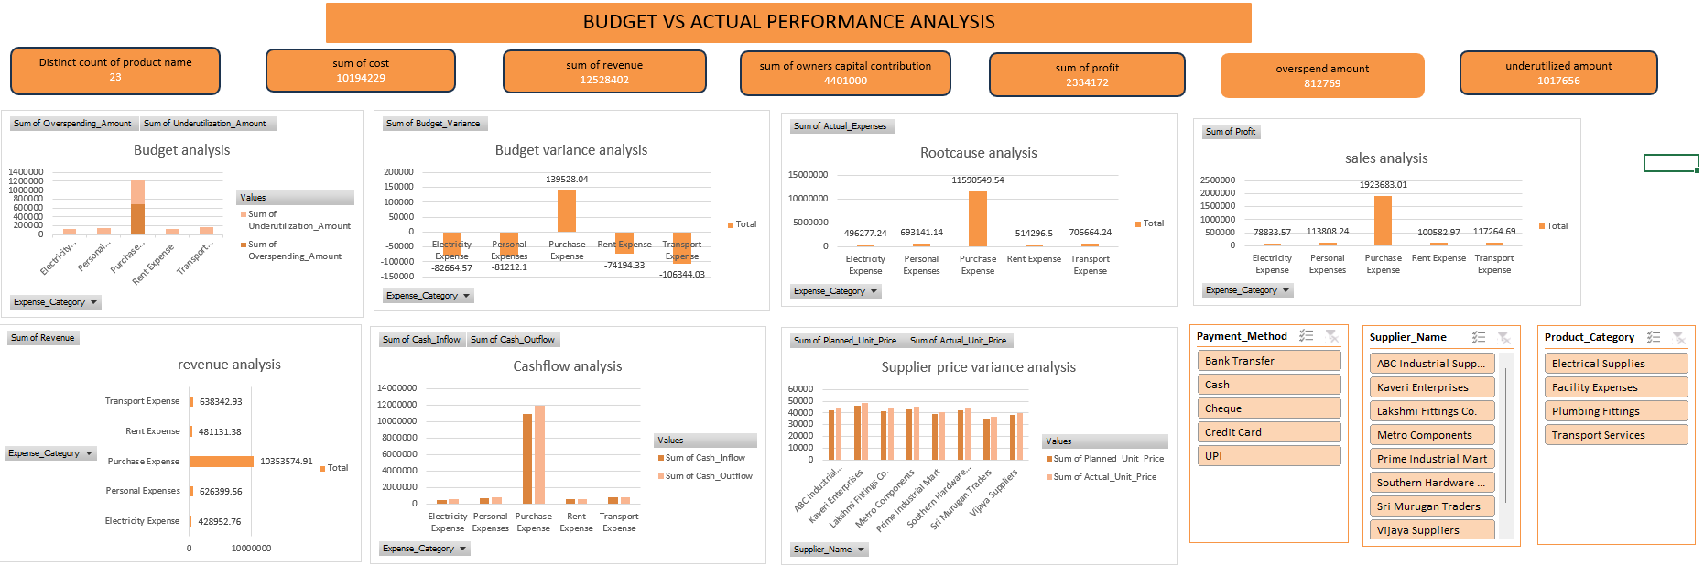
Overall, the dashboard helps identify major expenses, budget deviations, cash flow patterns, supplier price differences, and profitability. The findings can support better financial planning, tighter cost control, improved cash flow management, and more informed business decisions.
OVERALL BUSINESS IMPROVEMENT PLAN
Control purchasing costs.
Improve budget planning and cash management by investigating overspending, underutilization, and cash flow differences.
Improve profitability by reviewing supplier prices and identifying products that generate the strongest profit margins.
FUTURE ENHANCEMENT
Optimize Inventory Management
Strengthen Cash Flow Management
Focus on Profitable Products
Reduce unnecessary expenses
REFERENCE
https://www.researchgate.net/publication/384537685_THE_BUDGETING_AND_FORECASTING_ANALYSIS_AND_THE_IMPACT_ON_COMPANY_FINANCIAL_PERFORMANCE_AND_STRATEGIC_DECISION-MAKING_A_CASE_OF_NATIONAL_FINANCE_OMAN
https://rsisinternational.org/journals/ijriss/articles/the-role-of-forecasting-and-budgeting-data-accuracy-in-improving-organizational-performance/
https://www.researchgate.net/publication/307569805_The_Use_of_a_Single_Budget_or_Separate_Budgets_for_Planning_and_Performance_Evaluation
https://www.researchgate.net/publication/408427387_Budgeting_Practices_and_Financial_Performance_of_Private_Secondary_Schools_in_Kagadi_District_Western_Region_Uganda
https://journalofbusiness.org/index.php/GJMBR/article/view/103107

